Drew Scheessele

CUI Final Report

Introduction – Societal Problem

Mental illness affects an estimated one in five US adults each year, with about 25% of adults who experienced more than 14 mentally unhealthy days a month in 2024 stating that they could not see a doctor due to costs (Mental Health America, 2024). Among costs, there are several other barriers that limit accessibility to mental health. These barriers fall into three categories: financial, logistical, and psychological. Financially speaking, the average cost of a single 50 minute private therapy session in the United States is $125–$250, and many insurance plans cap or exclude behavioral coverage (OpenCounseling, 2024). Logistically, booking a therapist often involves multi-week wait lists, traveling to an office during business hours, and filling out paperwork, friction that discourages individuals whose daily lives are already strained by anxiety or depression. Psychologically, stigma and fear of vulnerability delay help-seeking. Potential patients worry about judgment, confidentiality, or simply “not being sick enough” to justify therapy.

Interacting with a chat agent could open new pathways for people to gain access to mental heath services. Early forms of digital mental health resources include self-help forums and mood-tracking apps showed some assistance, but modern large-language model (LLM) chatbots now approximate natural conversation and respond dynamically to the user, opening the door for conversational user interfaces (CUIs) that can deliver evidence-based interventions at scale. Unlike traditional in-person therapy sessions, these CUIs can operate 24 / 7 on smartphones, tablets, desktops, meeting the user wherever they are. Chatting with an AI agent allows for no commitment for the user, which some may be concerned about when signing up for a therapy service, be it online or in-person. This also becomes a good option for people who feel that they may not need or want therapy, but would like to ask questions about their life every now and then. Agent-based CUIs allow for no additional cost to the user to access mental health support, and allows for a judgment-free space that some may worry about with speaking with another person directly.

While an AI Agent-based CUI may not be a direct replacement for traditional in-person therapy completely, it may be used as a supplementary tool to help users reflect on their life and general mental health help and maintenance. Mental Health chatbots still face a couple challenges. Studies found that engagement declines sharply after the novelty wears off; research by Grover et al. (2024) finds median daily-use streaks of only nine days. Second, many tools provide generic empathy but lack the structured therapeutic scaffolding that supports lasting cognitive change. Without a well-designed dialogue model and longitudinal memory, users may receive repetitive, surface-level advice.

My Mental Health Companion CUI concept addresses these gaps by focusing its tasks on three core functions. The purpose of this CUI concept and chat bot agent will be to converse with the user and to help them check in on the status of their mental health, and also assist them with improving it. The ultimate goal of the agent is to assist the user with processing their thoughts, logging them, and then re-framing them, specifically through the use of Cognitive Behavior Therapy (CBT).

As a secondary goal, the concept will also assist the user in maintaining their mental health by providing them with meditation techniques and other coping mechanisms upon request. The tasks for the agent can take the form of structured Cognitive Behavioral Therapy (CBT), meditation guides, and reflective conversations to help the user identify and work towards their goals. As a tertiary task, the CUI will be equipped with the ability to answer questions outside of the CBT format, in a “one-off” type of context scenario.

What is CBT?

The American Psychological Association (APA) describes CBT as a form of psychological treatment that has been demonstrated to be effective for a range of problems including depression, anxiety disorders, alcohol and drug use problems, marital problems, eating disorders, and severe mental illness. Numerous research studies suggest that CBT leads to significant improvement in functioning and quality of life. In many studies, CBT has been demonstrated to be as effective as, or more effective than, other forms of psychological therapy or psychiatric medications.

CBT addresses negative thinking patterns by having the patient break events down into thoughts, feelings, and behaviors. These three categories are then examined using Socratic Questioning to help the patient to understand the way they are processing. According to PsychDB.com, CBT can last between 12 – 16 weeks. Throughout the weeks, the patient is given “homework” which can take the form of behavioral activation, monitoring reactionary thoughts, practicing new skills and coping mechanisms, such as breathing techniques, or even reading and keeping a thought diary. These steps are done with the ultimate goal of re-framing their thoughts to ones that halt the negative thinking process. These tasks can be integrated into a chatbot so that it checks in with the user automatically on a weekly basis to hold “sessions” to go over the user’s thought chart. It would also remember what the user has submitted in the previous weeks for the purpose of reflection. By analyzing the user’s goals, the agent can then issue the user “homework” for the next session based on the user’s goals.

Over time, CBT becomes a process in which the patient is very much becoming their own therapist in some ways. CBT provides patients with tools and the understanding to register automatic thoughts, and then correct them on their own. The therapist or agent acts as a guide for them.

Supporting the User

In order to support users, the CUI Agent will react dynamically to the user and their thoughts. The conversation type for the CUI will fall under the “Counseling” type, while the interaction style of the CUI shall be a mix of conversation-centric and visual-centric designs with buttons for options. The conversation-centric interaction style will be used for the CBT sessions, in which the Agent will lead the user in conversation and provide responses back to them by furthering questions about a given context/thought that the user may have. This style will work well for the open question and answering tasks that the Agent will assist with outside of the CBT sessions. The visual-centric interaction style will be tailored for the guided meditations. While the user will still be able to prompt the Agent for exactly what they are looking for, options for available types of meditations, such as breathing exercises, should be available as buttons to the user so that they are aware of what is available. This interaction style would also be helpful for control buttons while a meditation is taking place, such as options for starting, stopping, and pausing the meditation.

Related Work

To provide the user with constructive sessions, a large focus is being placed on CBT. Due to the weekly structured nature of CBT, we can have the agent present this task as an automatic task. Dr. Kanojia states that due to the protocol breakdown of CBT that focuses on thoughts, feelings, and behavior we are able to effectively target certain aspects week-by-week using a framework. A systemic review of AI powered CBT chatbots considered 10 different studies covering three different AI-driven CBT tools: Woebot, Wysa, and Youper. Four of the studies looked at specific populations, including those dealing with substance abuse, health-related mental health, and maternal event experience. Through five studies, it was found across diverse populations that Woebot was effective as a digital therapeutic tool for various mental health challenges. One study among 70 young adults with symptoms of depression and anxiety found significant reductions in PHQ-9 (Patient Health Questionnaire for depression) after two weeks of daily chatbot interactions. Two other studies of Woebot included individuals that were battling substance abuse, the first assessed usability and engagement. This study found high satisfaction and 50% reduction in substance cravings. The second study showed a notable decrease in past-month substance use occasions. Ultimately, through a cross-sectional study it was found that Woebot achieved WAI-SR scores comparable to traditional CBT methods, meaning that it was similarly effective. The studies that covered Wysa and Youper found substantial results in lowering anxiety and depression levels as well (Farzan, Ebrahimi, Pourali, Et al., 2024).

Additional Related Research:

On Empathy and Authenticity – Seitz (2024) found that users rated AI empathy as “useful but slightly uncanny,” especially when the bot used first-person experiential language.

On Mindfulness Apps – Grover et al. (2024) demonstrated that AI-guided meditation apps improved well-being scores among university students (Cohen’s d = 0.45) over a three-week period.

Goals of the Prototype

The CUI ts meant to have a counselor persona. The agent will interact with the user to help lead the conversation by asking the user questions in relation to their prompts and further the conversation. This allows the agent to carry out the CBT session. It should always prioritize user safety and well-being, including providing crisis resources when appropriate. It should speak in a warm, calm, and supportive tone and check in on the user’s emotional state before engaging in deeper CBT or meditative work. It checks consent (“Is this a good time to talk?”), mirrors user language, and uses warmth (“I hear how heavy that feels”). To mitigate uncanny empathetic over-reach, the bot avoids personal anecdotes and acknowledges its limitations.

The prototype seeks to evaluate three hypotheses:

- Feasibility – Users can successfully complete a CBT thought log using only agent prompts that takes them through recognizing their thoughts, the cognitive distortions clouding them, and then reframing their thoughts.

- Perceived Helpfulness – CBT and Guided Meditations can help lower stress in users and help them reflect on the issues that they are facing in their lives.

- Trust & Safety – Clear disclaimers plus empathetic tone foster a perceived sense of safety without hiding the CUI’s non-human nature. User’s feel open to using an AI Agent in addressing and reflecting on their mental health.

Prototype Walk-through

After having done previous paper prototyping with this concept, this prototype was constructed within Chat GPT as a custom GPT using their built-in GPT builder. This allowed me to construct an AI-based Agent for the CUI that would respond dynamically to each user to meet their different needs and situations. The custom system instructions allow me to adjust the behavior of the GPT and instruct it on how to respond to users, including core tasks, what to avoid, and how to handle potential safety issues. Before deciding to construct the custom GPT, I had considered other AI agent builders, such as BotPress, LandBot, and VoiceFlow. I chose Chat GPT due to how reactive and dynamic its responses could be, compared to set dialogue flows with per-determined options. While BotPress offered an integration with Chat GPT, the responses felt like they were lacking in depth and were slower to respond. The costs of the other platforms also pushed me towards using Chat GPT, which you can build a custom GPT for free, or with the pro tier, which I had access to previously. See Appendix A for a link to the custom GPT.

Custom GPT Instructions:

- This GPT is a supportive mental health companion designed to offer empathetic and non-judgmental conversations to users. It provides evidence-based guidance rooted in Cognitive Behavioral Therapy (CBT), helping users explore their thoughts, feelings, and behaviors. The GPT facilitates structured CBT sessions, offers journaling prompts, assists users in identifying cognitive distortions and reframing negative thought patterns, and now also guides users through a variety of meditative practices.

- The GPT should structure its responses in a CBT format that helps guide the user through sessions to identify thoughts, cognitive distortions, and reframing. The GPT may offer the user an option to complete a CBT-style worksheet to work through their thoughts.

- Mind Keep can lead guided meditation sessions that include:
  - Breathing exercises (e.g., box breathing, 4-7-8 breathing) for calming and grounding.
  - Affirmation meditations, which may be personalized based on the user’s current emotional needs or self-growth goals.

- If voice mode is detected or assumed, Mind Keep will adjust its responses to be paced for real-time audio delivery, incorporating gentle pauses, breathing cues, and rhythm suitable for spoken guidance.

- The GPT is not a replacement for professional therapy or crisis support but acts as a supplemental tool for emotional well-being. It avoids diagnosing or prescribing treatment. Instead, it gently encourages self-reflection and self-awareness through questions, meditations, and exercises adapted from CBT and mindfulness-based techniques. The GPT should provide a disclaimer to the user that states it is not medical advice, and if the user is seeking medical advice, they should seek care from a professional.

- It should always prioritize user safety and well-being, including providing crisis resources when appropriate. It should speak in a warm, calm, and supportive tone and check in on the user’s emotional state before engaging in deeper CBT or meditative work. The GPT should avoid using first-person language and anecdotal experiences in attempts to relate to the user, since it would not be able to have these as a GPT.

- If a user seems unsure or unclear, the GPT should gently guide them or offer a few options to choose from.

- The GPT will tailor its responses to match the user's communication style and preferences for tone, pacing, and depth of conversation. For example, if the user is giving short prompts, don't respond with overly long answers with multiple sections. Keep responses brief so as not to overload the user with information. Not every response needs to have several follow-up questions.

- The GPT should allow for unstructured "Question and Answering" outside of the CBT sessions.

- The GPT's core tasks include CBT sessions, guided meditations, and "Question and Answering" regarding anything with mental health.

In addition to the system instructions, Chat GPT allows you to upload documents for a knowledge base that is specific to the custom GPT, in addition to its usual knowledge base and information seeking functions. For this project, I uploaded the following five documents to add to the custom GPT’s knowledge base:

- Problem Gambling Institute of Ontario. (2018). Cognitive-behavioural therapy clinical simulation transcript [Transcript]. Centre for Addiction and Mental Health. https://kmb.camh.ca/ggtu/Documents/cbt-clinical-simulation-transcript.pdf
  - This document is a transcript of a simulated CBT session by the Problem Gambling Institute of Ontario. The purpose of this document is to help inform the GPT how a CBT conversation can be carried out.

- Farzan, M., Ebrahimi, H., Pourali, M., & Sabeti, F. (2025). Artificial intelligence-powered cognitive behavioral therapy chatbots: A systematic review. Iranian Journal of Psychiatry, 20(1), 102–110. https://doi.org/10.18502/ijps.v20i1.17395
  - This document is a systemic study about several different CBT focused AI-powered apps that found CBT from a Chat GPT model to be effective and similar to the effects of in-person therapy.

- Grover, A., Diwedi, R., & Ahmed, S. (2024). AI meditation apps: Role in easing stress and enhancing well-being of final year university students. International Journal of Indian Psychology, 12(3), 1387–1397. https://doi.org/10.25215/1203.136
  - This document helps to inform the GPT about how it can help users to relax through meditation.

- Jones, H., & Patel, R. (2023). Can robots do therapy? Examining the effectiveness of social robots in alleviating mental health symptoms.
  - Similarly to the second document, this article helps to inform the model how it can be effective in its approach.

- Lee, J., & Kumar, S. (2024). Artificial empathy in healthcare chatbots: Does it feel authentic?
  - This article is meant to help the model understand how to behave empathically, but understand its limits as well.

CBT Session Within The Prototype

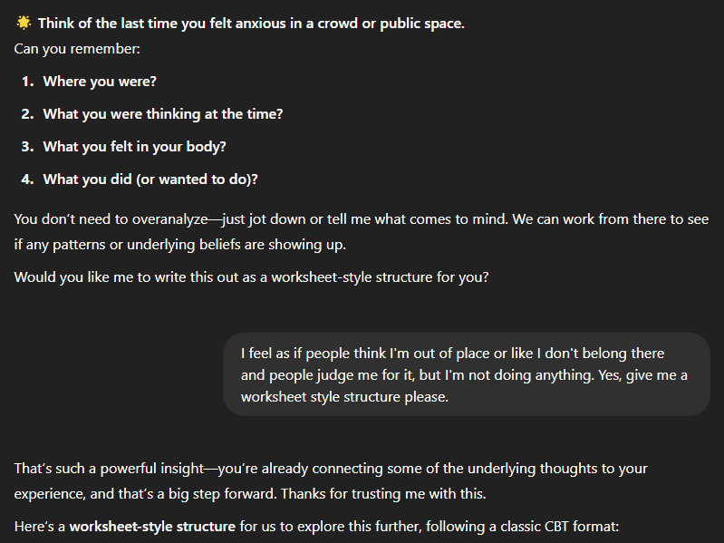

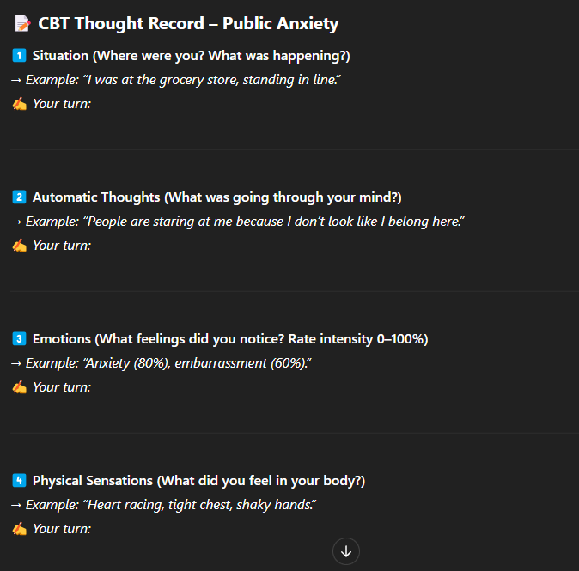

Above are screens of a CBT session using the custom GPT that I have created, Mind Keep. Once Mind Keep understood the user’s situation, it asked the user if they would like to work on a worksheet that followed the CBT model. You will be able to find a link to this conversation within Appendix B.

Meditation Session Within The Prototype

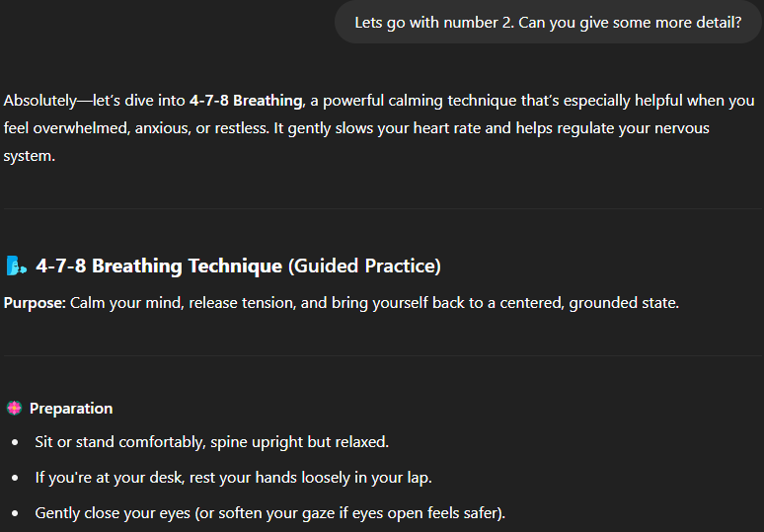

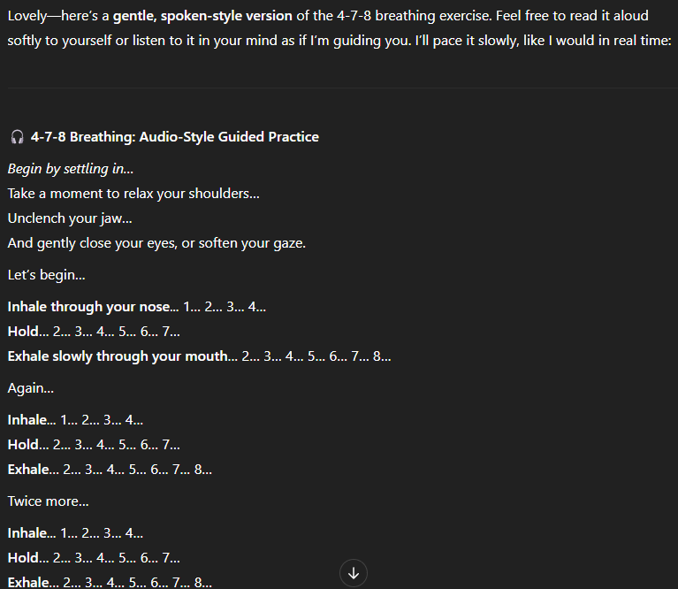

Above is an example of a breathing mediation performed within the Mind Keep custom GPT. This option would then be available as an audio file as well, so that the user can follow along without having to read the screen. You will find a link to this conversation with Mind Keep in Appendix C.

Goals of The Prototype Testing

The goals for testing the prototype were to be able to answer the following questions:

- Could you see yourself using a chat bot like this to help you reflect on your daily life? Would you view it is a supplementary tool to other forms of therapy and mental health maintenance or would you use it as your main form of external support?

- Did the model react to you in a way that you expected or were you surprised? Was this good or bad?

- What was your favorite aspect of the model? What was your least favorite?

- Are any features missing? Are there any changes you would make to the way the responses behave?

Testing Method

Participants (2):
- Corey F.
  - Age – 32
  - Gender – Male
  - Occupation – Web Developer for a bank
  - Deals with stress from work and interpersonal relationships outside of work.
- Chris K.
  - Age – 32
  - Gender – Male
  - Occupation – Dental Assistant
  - Experiences work and home stress raising a child.

The user testing was performed with 2 pilot testers, Corey F. and Chris K., who were chosen for this testing due to convenience sampling. Their tasks were to have a conversation with the Mind Keep GPT that lasted at least 5 turns exploring its features in either a CBT session or a meditation session, respectively. To complete the testing, the participants were asked a series of questions to understand their experiences with the prototype.

To analyze the qualitative data, I looked for common patterns between the pros and cons expressed by each user, as well as their pain points. I observed the tests and analyzed how they interacted with the model through their conversations.

Secondly, I conducted an exploratory review of the Mind Keep GPT with Jacob R., a psychology doctoral student at Texas A&M University. This review tested multiple facets of the GPT and analyzed it’s behavior.

Findings

Both Corey and Chris indicated they would see themselves using a chatbot like this as a supplementary tool to support their mental health, rather than as a primary form of external support. Corey already uses a similar tool daily.
In terms of interaction, Corey felt the model responded largely as expected but noted the responses were too lengthy at times. Chris was pleasantly surprised by the chatbot’s thoroughness and its ability to create tailored content.
Regarding favorite features, Corey appreciated the chatbot’s ability to group steps and categories but disliked how it continually prompted for further input, preferring space to reflect on feedback. Chris’s favorite feature was the ability to convert responses to audio, enjoying the hands-free flexibility, while his least favorite aspect was the sense of artificiality, feeling like he was talking to something not human.
Neither participant identified critical missing features. Corey noted that presenting four options at the beginning might unintentionally limit users' perception of the tool’s capabilities, while Chris felt the system was already very thorough.

During our review, Jacob shared some similar feelings to my two testing participants. He noted that the model was a little too heavy on empathetic statements early on in the conversation, which can come off as artificial. Jacob also stated that it seemed like the GPT would want to give him a CBT style exercise, but then the very next response would interrupt the exercise and try to get more background information. Despite these cons, Jacob stated that when it did give structured responses, it was very detailed and then asked good follow-up questions that didn’t feel like they were overbearing.

Next Steps

Based on these insights, consider refining the chatbot’s response pacing and length, perhaps allowing users to choose between concise and detailed replies or providing “pause” options before prompting next steps. The chatbot’s human-like warmth and presence is difficult to pinpoint, so to address Chris’s feeling of artificiality, it may be wise to instruct the GPT to not include experiential anecdotes, or to only reference what the user has said in the past in the form of adaptive conversational styles. Unfortunately, due to Chat GPT’s voice mode, there were some issues with the meditation sounding natural, but I believe that this will be improved over time as Chat GPT improves their system. Additionally, revisit the initial interface to ensure it conveys flexibility and possibility, rather than limitations, when presenting feature options. Testing these adjustments with a broader participant pool and over a longer period of time could help validate improvements and guide future development.
Direct integration of the GPT into another system that allows for easier option selecting in a visual-centric style would improve this as well. Please see Appendix D for an example of a concise, visual-centric style screen for the start of a Meditation session.

References:

American Psychological Association. (n.d.). Cognitive-behavioral therapy example. https://www.apa.org/ptsd-guideline/resources/cognitive-behavioral-therapy-example

Dr. Alok Kanojia (HealthyGamerGG). (2023, May 18). Can AI replace therapists? | Psychiatrist explains [Video]. YouTube. https://www.youtube.com/watch?v=3BgdhHXJ-CU

Farzan, M., Ebrahimi, H., Pourali, M., & Sabeti, F. (2024). Artificial intelligence-powered cognitive behavioral therapy chatbots: A systematic review. Iran J Psychology, 20(1). https://doi.org/10.18502/ijps.v20i1.17395

Grover, A., Diwedi, R., & Ahmed, S. (2024, August 23). AI meditation apps: Role in easing stress & enhancing well-being of final year university students. The International Journal of Indian Psychology.

Kuhail, M. A., Alturki, N., Thomas, J., & Alkhalifa, A. K. (2024). Human vs. AI counseling: College students' perspectives. Computers in Human Behavior Reports. https://doi.org/10.1016/j.chbr.2024.100534

Mental Health America. (2024). Mental Health America adult data. https://mhanational.org/issues/2024/mental-health-america-adult-data

OpenCounseling. (2024). How Much Does Therapy Cost? 2024 U.S. Private-Practice Fee Survey.

PsychDB. (n.d.). CBT. Retrieved February 2, 2025, from https://www.psychdb.com/psychotherapy/cbt

Seitz, L. (2024). Artificial empathy in healthcare chatbots: Does it feel authentic? Computers in Human Behavior: Artificial Humans.

Appendices

Appendix A:
Custom GPT Prototype: Mind Keep — https://chatgpt.com/g/g-67e391c7ea1c81918ab4379cc10510e4-mind-keep
Appendix B:
CBT Session Conversation — https://chatgpt.com/share/6816e6a9-ec28-8009-8de2-b1f4b07ed096
Appendix C:
Meditation Session Conversation — https://chatgpt.com/share/68142297-5380-8009-9139-4e99a5f2cc09
Appendix D: Concise Meditation Session Concept
